**Access Modifiers in java->**

*There are two types of modifiers in java: **access modifiers** and **non-access modifiers**.

The access modifiers in java specifies accessibility (scope) of a data member, method, constructor or class.

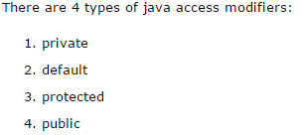

*There are many non-access modifiers such as static, abstract, synchronized, native, volatile, transient etc. Here, we will learn access modifiers.

**1.private access modifier->**

The private access modifier is accessible only within class.

### **Simple example of private access modifier->**

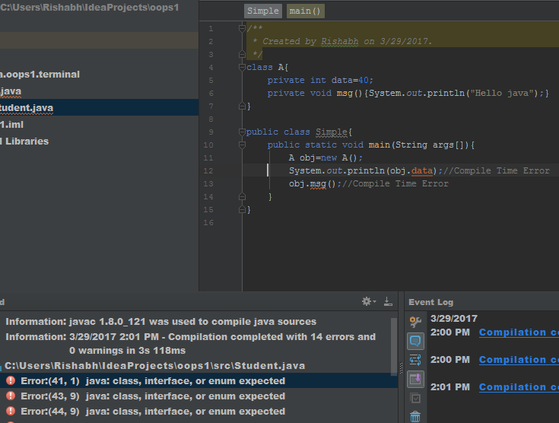

*compile time error h

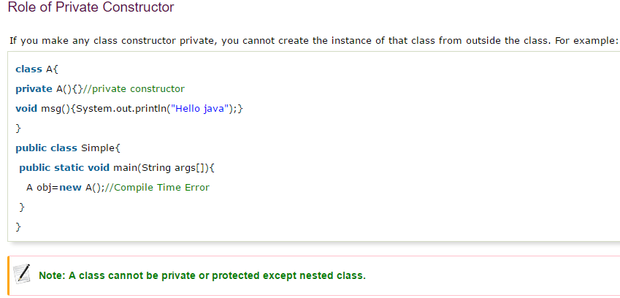

### **2) default access modifier->**

**If you don't use any modifier, it is treated as default bydefault. The default modifier is accessible only within package.**

### **Example of default access modifier**

|  |
| --- |
| In this example, we have created two packages pack and mypack. We are accessing the A class from outside its package, since A class is not public, so it cannot be accessed from outside the package. |

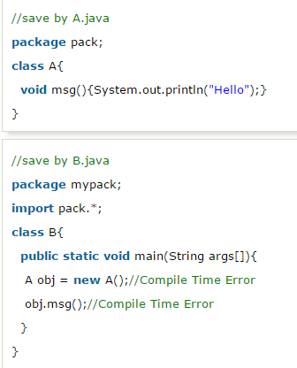

### **3) protected access modifier->**

*The **protected access modifier** is accessible within package and outside the package but through inheritance only.

*The protected access modifier can be applied on the data member, method and constructor. It can't be applied on the class.

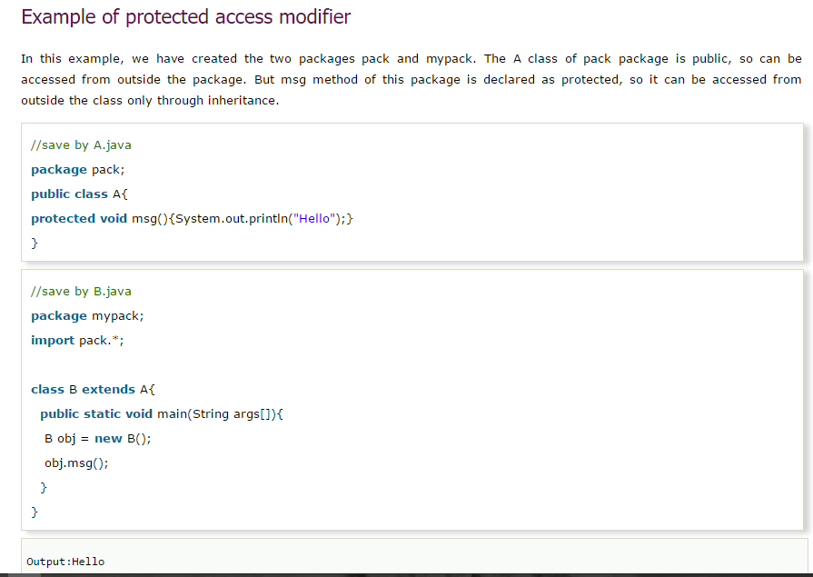

### **4) public access modifier->**

*The **public access modifier** is accessible everywhere. It has the widest scope among all other modifiers.

